993M

JERZEES
Full Zipper
Hooded Sweatshirt

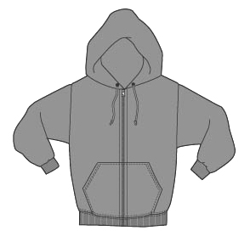

Descriptions
*50/50 Cotton poly NuBlend, 8 Ounce fleece
*Ribbed cuffs & waistband
*Muff pocket
*Single ply hood with grommets & matching drawstring
*Coverseamed waistband
*Set in sleeves
*Embroidery or screenprinting okay

Finished Garment Measurements

Size | S | M | L | XL | 2XL | 3XL
Length | 27 | 28 | 29 | 30 | 31 | 32
Width | 20 | 22 | 24 | 26 | 28 | 30
Sleeve Length | 35 | 36 | 37 | 38 | 39 | 40
Zipper | 26 | 27 | 28 | 29 | 30 | 31

